

**DBMS PROJECT REPORT**

on

**Blood Bank Management**

*Learning Activity-2 of Course: Database Management Systems Lab(18CSL47)*

Submitted by:

|  |  |
| --- | --- |
| Ayush Dewan | 1NT17CS026 |
| D. Likhith Ashwin | 1NT18CS032 |
| Anubhav Yadav | 1NT18CS017 |

|  |  |  |
| --- | --- | --- |
|  | **Nitte Meenakshi Institute of Technology**  (AN AUTONOMOUS INSTITUTION AFFILIATED TO VISVESVARAYA TECHNOLOGICAL UNIVERSITY, BELGAUM)  PB No. 6429, Yelahanka, Bangalore 560-064, Karnataka  Telephone: 080- 22167800, 22167860  Fax: 080 - 22167805 |  |

**Department of Computer Science and Engineering**

**CERTIFICATE**

This is to certify that the project titled “Blood Bank Management System” is an authentic work carried out by **Ayush Dewan (1NT17CS024), D. Likhith Ashwin (1NT18CS032) & Anubhav Yadav (1NT18CS017)** bonafide students of **Nitte Meenakshi Institute of Technology**, **Bangalore** in partial fulfilment for the Learning Activity -2 of the course Introduction to Database Management System Lab(18CSL47) in COMPUTER SCIENCE AND ENGINEERING of Visvesvaraya Technological University, Belagavi during the academic year ***2019-2020.***

|  |  |  |
| --- | --- | --- |
| **Internal Guide** |  | **Signature of the HOD** |
|  |  |  |
| Mr.Vinay T. R.  Assistant Professor, Dept. CSE, NMIT Bangalore |  | Dr.Thippeswamy M. N.  Professor, Head, Dept. CSE, NMIT Bangalore |

**INDEX**

|  |  |  |
| --- | --- | --- |
| **Serial No** | **TOPICS** | **Page No.** |
| **1** | **INTRODUCTION** | **4** |
| **2** | **QUERIES** | **5 to 8** |
| **3** | **ER DIAGRAM** | **9** |
| **4** | **CONCLUSION** | **10** |

**INTRODUCTION**

The main aim of blood bank management mini DBMS project is to ease the process of blood donation and allowance at blood bank. The aim to demonstrate the use of create, read, update and delete MySQL operation through this project. This project starts by adding details of staff of blood bank. once, registration is done staff can add blood donor details with Name, date of birth, blood group, city of residence, remarks, etc. now, when patient is in need of blood staff members can easily check that blood group available and provide it to the blood receiver.

OBJECTIVES:

1. Add and maintain Patient and staff details.
2. To provide a convenient solutions to hospital.
3. Make an easy to use environment for users.

**QUERIES**

1. **List all the name of donors who are eligible for donating A- blood and don’t have any of health condition.**

Select fname, lname, bloodgp, gender, remarks as Health_Issues from donor where bloodgp = 'A-' and remarks = 'no';



1. **Show the names of donor and their city who are from Karnataka.**

select fname as Initial, lname as Last,

case

when cityid = 1 then 'Bengaluru'

when cityid = 2 then 'Belagavi'

when cityid = 3 then 'Tumkur'

end as CityName

from donor where cityid in (select cityid from city where state = 'karnataka');

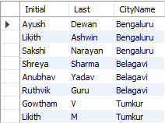

1. **Count the no of donors year wise who are born between 1995 and 2000 and order them by year of birth.**

select year(dob) as Year, count(year(dob)) as Count from donor where year(dob) between 1995 and 2000 group by year(dob) order by dob;

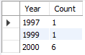

1. **Find the sum and average salary of male and female staff members separetly?**

select sum(salary) as TotalSalary, avg(salary) as AvgSalary from staff where gender = 'male'

union

select sum(salary), avg(salary) from staff where gender = 'female';



1. **Find the salary difference of the highest and lowest staff earner.**

select max(salary)-min(salary) as Salary_Difference from staff;



1. **In which city does Dr. Raj lives?**

select cityname from city where cityid in (select cityid from staff where job like 'd%' and lname = 'raj');



1. **How many ladies have donate blood?**

select count(did) as Times_Donated from bloodbank where did in (select did from donor where gender ='female');



1. **Select packet id which contains either ab+ or ab- blood?**

select PacketID from bloodbank where did in (select did from donor where bloodgp like 'ab%') order by packetid;

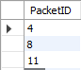

1. **Show the packet ids of the blood packets which are donated by the citizens of Maharashtra?**

select * from bloodbank where did in(select did from donor where cityid in(select cityid from city where state = 'Maharashtra'));

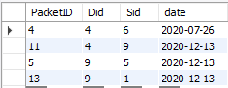

1. **List all the days on which blood bank collected blood?**

select distinct date from bloodbank;

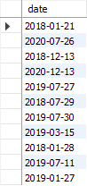

1. **Create view of the donors residing in Bangalore. Show the necessary details which can be given to campaigning team for blood donation.**

create view Bangalorians as select fname, lname, phoneno from donor where cityid = 1;

select * from Bangalorians;

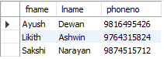

ER DIAGRAM

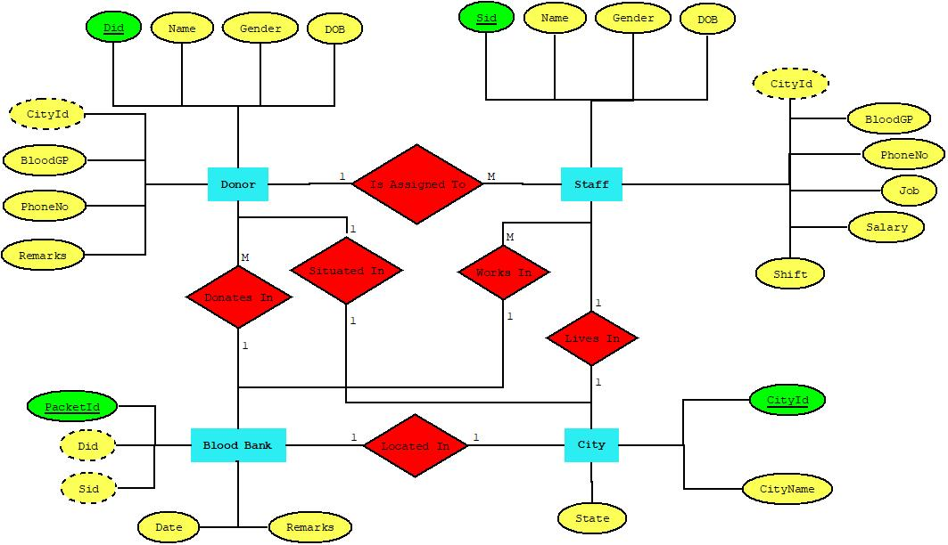

**CONCLUSION**

Throughout this project we understood the process of designing a database along with building an application using that database.

We thoroughly became familiar with the each step involved in this including the importance of proper planning and designing which hugely effects the further stages.

Blood Bank Management System is a very essential part of our society and helping the system with an online platform to manage their large and sorted database.

We have developed a web platform for it which is mobile computable but in the future we want to further expand this by developing an app that can be used by the users with ease.